<https://www.nytimes.com/interactive/2014/08/13/us/starbucks-workers-scheduling-hours.html>

Working Anything but 9 to 5

Scheduling Technology Leaves Low-Income Parents With Hours of Chaos

By **JODI KANTOR**, Photographs by **SAM HODGSON**

AUGUST 13, 2014

SAN DIEGO — In a typical last-minute scramble, Jannette Navarro, a 22-year-old Starbucks barista and single mother, scraped together a plan for surviving the month of July without setting off family or financial disaster.

In contrast to the joyless work she had done at a Dollar Tree store and a KFC franchise, the $9-an-hour Starbucks job gave Ms. Navarro, the daughter of a drug addict and an absentee father, the hope of forward motion. She had been hired because she showed up so many times, cheerful and persistent, asking for work, and she had a way of flicking away setbacks — such as a missed bus on her three-hour commute — with the phrase, “I’m over it.”



Jannette Navarro at Starbucks.

Newly off public assistance, she was just a few credits shy of an associate degree in business and talked of getting a master’s degree as some of her co-workers were. Her take-home pay rarely topped $400 to $500 every two weeks; since starting in November, she had set aside $900 toward a car — her next step toward stability and independence for herself and her 4-year-old son, Gavin.

But Ms. Navarro’s fluctuating hours, combined with her limited resources, had also turned their lives into a chronic crisis over the clock. She rarely learned her schedule more than three days before the start of a workweek, plunging her into urgent logistical puzzles over who would watch the boy. Months after starting the job she moved out of her aunt’s home, in part because of mounting friction over the erratic schedule, which the aunt felt was also holding her family captive. Ms. Navarro’s degree was on indefinite pause because her shifting hours left her unable to commit to classes. She needed to work all she could, sometimes counting on dimes from the tip jar to make the bus fare home. If she dared ask for more stable hours, she feared, she would get fewer work hours over all.

“You’re waiting on your job to control your life,” she said, with the scheduling software used by her employer dictating everything from “how much sleep Gavin will get to what groceries I’ll be able to buy this month.”

Last month, she was scheduled to work until 11 p.m. on Friday, July 4; report again just hours later, at 4 a.m. on Saturday; and start again at 5 a.m. on Sunday. She braced herself to ask her aunt, Karina Rivera, to watch Gavin, hoping she would not explode in annoyance, or worse, refuse. She vowed to somehow practice for the driving test that she had promised her boyfriend she would pass by the previous month. To stay awake, she would formulate her own behind-the-counter coffee concoctions, pumping in extra shots of espresso.



A sign with a missed deadline hanging in the kitchen.

Scheduling Chaos

Like increasing numbers of low-income mothers and fathers, Ms. Navarro is at the center of a new collision that pits sophisticated workplace technology against some fundamental requirements of parenting, with particularly harsh consequences for poor single mothers. Along with virtually every major retail and restaurant chain, Starbucks relies on software that choreographs workers in precise, intricate ballets, using sales patterns and other data to determine which of its 130,000 baristas are needed in its thousands of locations and exactly when. Big-box retailers or mall clothing chains are now capable of bringing in more hands in anticipation of a delivery truck pulling in or the weather changing, and sending workers home when real-time analyses show sales are slowing. Managers are often compensated based on the efficiency of their staffing.

Scheduling is now a powerful tool to bolster profits, allowing businesses to cut labor costs with a few keystrokes. “It’s like magic,” said Charles DeWitt, vice president for business development at Kronos, which supplies the software for Starbucks and many other chains.

Yet those advances are injecting turbulence into parents’ routines and personal relationships, undermining efforts to expand preschool access, driving some mothers out of the work force and redistributing some of the uncertainty of doing business from corporations to families, say parents, child care providers and policy experts.

In Brooklyn, Sandianna Irvine often works “on call” hours at Ashley Stewart, a plus-size clothing store, rushing to make arrangements for her 5-year-old daughter if the store needs her. Before Martha Cadenas was promoted to manager at a Walmart in Apple Valley, Minn., she had to work any time the store needed; her mother “ended up having to move in with me,” she said, because of the unpredictable hours. Maria Trisler is often dismissed early from her shifts at a McDonald’s in Peoria, Ill., when the computers say sales are slow. The same sometimes happens to Ms. Navarro at Starbucks.

By Saturday afternoon of the Fourth of July weekend, Ms. Navarro had made it through “clopening,” closing late at night and opening again just a few hours later. But she had not yet worked up the courage to ask Ms. Rivera and Ms. Rivera’s boyfriend, Oscar Nuñez, for help the next day with Gavin.



Gavin with Oscar Nuñez.

The couple had repeatedly given her safe harbor over the years: when Ms. Navarro’s mother abandoned her at the age of 17, and then died of an overdose; when Gavin’s father disappeared without paying child support. But since Ms. Navarro started at Starbucks, her job had often spilled over into the lives of Ms. Rivera and Mr. Nuñez so that they had trouble juggling their own jobs — Ms. Rivera’s as a dental assistant and his as a mechanic — or making plans with their two toddlers. “It puts a strain on the whole household, on my relationship with Karina,” said Mr. Nuñez, 38.

Weekends, when Gavin’s day care center is closed, were particularly charged; on top of that, the couple disapproved of Ms. Navarro’s boyfriend, Nick Martinez. The tension culminated one night last winter, with all four adults screaming at one another on the front lawn. After that encounter, Ms. Navarro moved in with Mr. Martinez, 22. But months later, she still depended on her aunt for help, and Gavin tended to cling to the couple, crying and asking to stay at their house.

“You’re not working tomorrow, are you?” Ms. Rivera finally asked. She had already watched Gavin all of Saturday morning, she had made beach plans for Sunday, and when she heard the answer she grew exasperated. “We can’t even do our own thing,” she told Ms. Navarro, who felt guilty and then surprised: Her aunt folded, saying she would take Gavin again.

With the crisis averted, Ms. Navarro reported to work before dawn the next morning, napping on the sidewalk for a few minutes before it was time for her to open the store.

Two days later, on July 8, she had to tug her son out of bed just as early, rousing Gavin before 5 a.m. for their long commute. But this time her boyfriend, Mr. Martinez, helped her get ready for the day. He had been a supportive force, inviting her and Gavin to share the bedroom he had in his sister’s apartment, enjoying moments of surrogate fatherhood with the little boy.

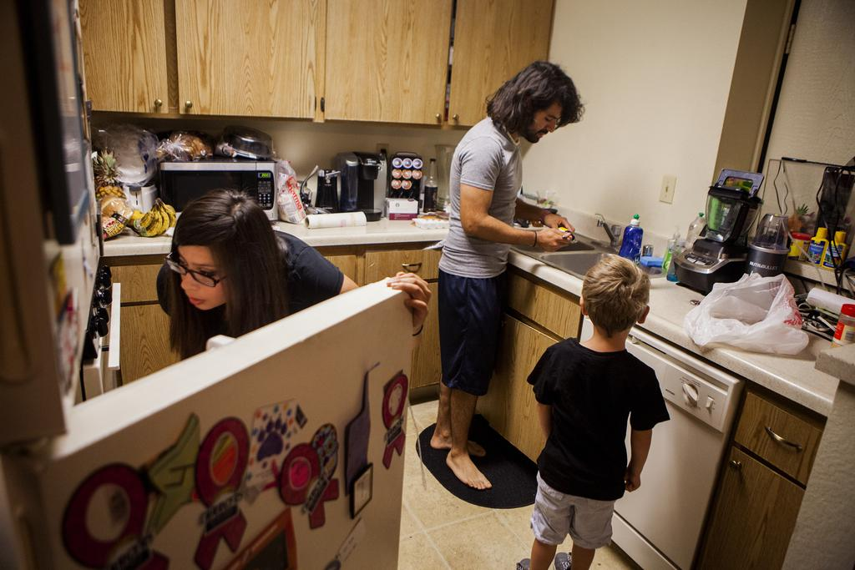



Ms. Navarro's boyfriend, Nick Martinez.

In turn, Ms. Navarro had helped Mr. Martinez get a job at her Starbucks store, and together they had become a team, both poor but pooling their resources to get ahead.

Ms. Navarro hated waking Gavin so early, but the trip from home to day care to work took a mile-long walk, two trolleys, a bus ride and over three hours.







Ms. Navarro's three-hour commute to day care and then work.

At the day care center, her scattered schedule created a perpetual blizzard of paperwork, with Ms. Navarro documenting her ever-changing hours, lest she lose the precious placement. She knew Gavin was fortunate to attend a preschool with live hermit crabs and Play-Doh sea urchins. Many other parents with unstable work schedules rely on ragtag coverage, paying neighbors or relatives small sums to watch their children.

Child care and policy experts worry that the entire apparatus for helping poor families is being strained by unpredictable work schedules, preventing parents from committing to regular drop-off times or answering standard questions on subsidy forms and applications for aid: “How many hours do you work?” and “What do you earn?”

“Some families drop their kids at 7:30 and then come back at 10:30 saying there was no more work for the day,” said Patricia Smith, director of the Jeff and Deni Jacobs Child Development Center, the government-funded day care Gavin attends.



Gavin at day care.

Once Gavin was settled at the day care center, Ms. Navarro raced onto another bus, panicked when it skipped her stop, got off and ran back to Starbucks, and walked in 10 minutes late.

Her co-workers asked her how she was, pointedly but not unkindly. Through the grapevine, they had heard the news that Ms. Navarro was struggling to accept: Mr. Martinez was breaking up with her, and she and Gavin would lose another home.

Mr. Martinez had told her the evening before, explaining that he had been feeling too weighed down and that he could not do what he wanted — go back to school and get a better job — amid the whirl of Ms. Navarro’s last-minute logistics. “I bit off more than I could chew,” he said later.

Her failure to find time to practice driving and get her license had sealed his decision: The deadline on the refrigerator had been his final one, and she had missed it. With no child of his own, he did not feel as stymied by the shifting hours as she did, and he blamed Ms. Navarro for failing to move ahead fast enough. “If you want something badly enough, you’ll get it done,” he told her.

She had spent the night on the couch, sobbing, panicking, envisioning how every bit of her hard-won progress could disappear. She and Gavin would have no place to live. He could be kicked out of day care for having no home address. With no day care, she would not be able to work.

“Things were finally starting to come into order,” she said, thinking back to how the month had started. She had believed in Mr. Martinez, in her own momentum, in her ability to put together the basic pieces of a life.

“I just want to be able to live happily and comfortably,” she explained in a text message afterward.

Tuesday evening, the three shared a final dinner, Ms. Navarro visibly trembling with anxiety and anger.

Gavin had no idea he was about to lose his second home in six months, or the man who had been treating him like a son. “What’s the drink I like to get?” Mr. Martinez asked Gavin on the way back from dinner. “Venti soy mocha!” said the small voice.



Dinner the day after Mr. Martinez broke up with Ms. Navarro.

Not Alone

Ms. Navarro’s erratic hours had not caused the crisis, but their effects had radiated outward, eroding nearly all of her plans and relationships.

Andrew Alfano, a senior vice president of retail at Starbucks, said that an experience like Ms. Navarro’s was an anomaly, and that the company provided at least a week’s notice of work hours, as well as stable schedules for employees who want them. However, in interviews with current and recent workers at 17 Starbucks outlets around the country, only two said they received a week’s notice of their hours; some got as little as one day.

“If for some reason we haven’t lived up to what we aspire to, it’s really disappointing,” Mr. Alfano said. “We want to know about it, we want to fix it.” Another spokesman said the company would reiterate its scheduling policies to managers across the country.

Like many employers, Starbucks also says that its variable hours can be a plus, adding that the coffee chain provides benefits — like health care, 401(k) matching, stock and tuition for online degrees — that many retailers do not. (Ms. Navarro said she was three classes shy of being able to transfer and take advantage of the tuition offer.)

But flexibility — an alluring word for white-collar workers, who may desire, say, working from home one day a week — can have a darker meaning for many low-income workers as a euphemism for unstable hours or paychecks. Legislators and activists are now promoting proposals and laws to mitigate the scheduling problems. But those who manufacture and study scheduling software, including Mr. DeWitt of Kronos, advocate a more direct solution: for employers and managers to use the software to build in schedules with more accommodating core hours.

“The same technology could be used to create more stability and predictability,” said Zeynep Ton, a professor at M.I.T. who studies retail operations.

Ms. Navarro turned out to be a case in point.

By August, she and Gavin were staying on an air mattress at the home of a former co-worker, with occasional nights at her aunt’s house, and no idea where they would go next. Gavin was crying more than usual, exhausted and unsure of where Mr. Martinez had gone. Over the past month she had downgraded her ambitions; the best she now hoped for was to be promoted to shift supervisor. The only happy news was that she had somehow passed her driving test.





Mr. Nuñez consoles Gavin, who is upset to leave, and Ms. Navarro gets ready to take Gavin to stay at her friend's.

[Continue reading the main story](https://www.nytimes.com/interactive/2014/08/13/us/starbucks-workers-scheduling-hours.html#story-continues-2)

**RELATED COVERAGE**

[[](http://www.nytimes.com/2014/08/15/us/starbucks-to-revise-work-scheduling-policies.html)](http://www.nytimes.com/2014/08/15/us/starbucks-to-revise-work-scheduling-policies.html)

[Starbucks to Revise Work Scheduling Policies AUG. 15, 2014](http://www.nytimes.com/2014/08/15/us/starbucks-to-revise-work-scheduling-policies.html)

[[](http://www.nytimes.com/2014/07/16/business/a-push-to-give-steadier-shifts-to-part-timers.html)](http://www.nytimes.com/2014/07/16/business/a-push-to-give-steadier-shifts-to-part-timers.html)

[A Push to Give Steadier Shifts to Part-Timers JULY 15, 2014](http://www.nytimes.com/2014/07/16/business/a-push-to-give-steadier-shifts-to-part-timers.html)

[[](http://www.nytimes.com/2012/10/28/business/a-part-time-life-as-hours-shrink-and-shift-for-american-workers.html)](http://www.nytimes.com/2012/10/28/business/a-part-time-life-as-hours-shrink-and-shift-for-american-workers.html)

[A Part-Time Life, as Hours Shrink and Shift OCT. 27, 2012](http://www.nytimes.com/2012/10/28/business/a-part-time-life-as-hours-shrink-and-shift-for-american-workers.html)

Then her wallet was stolen, leaving her without even a bus pass. Ms. Navarro was so desperate that she finally threw herself on her manager’s mercy, taking her into the back room to explain the misery of her situation and plead for more and better hours. “I need the full 40,” she said, slumped on the floor because she was too tired to stand.

Later, asked by a reporter about Ms. Navarro’s situation, a Starbucks spokesman said the company would work to stabilize her schedule.

Even before then, Ms. Navarro’s manager was taking a closer look at her hours. A few days after their discussion, a new schedule appeared. Ms. Navarro would still have to arrive before dawn on the weekend. But she would now work nearly 40 hours a week, which happened rarely before. And for three precious weekdays, her job at Starbucks, her job as a mother and the day care schedule would be in alignment: She would start around 8 in the morning and finish around 4.